**Organic Chemistry Ⅱ (Midterm Exam)**

1. (a) 4 (2%)

(b) 2 (2%)

(c) 4 (2%)

(d) 6 (2%)

(e) 12 (2%)

(a) and (e) (4%)

(a) No reaction (3%)

(b) No reaction (3%)

(a) Antiaromatic (1%)

(b) Nonaromatic (1%)

(c) Nonaromatic (1%)

(d) Nonaromatic (1%)

(e) Antiaromatic (1%)

(f) Aromatic (1%)

(g) Aromatic (1%)

(h) Aromatic (1%)

(i) Aromatic (1%)

(j) Aromatic (1%)

1. How might you convert 1,3,5,7-cyclononatetraene to an aromatic substance? (4%)



1. Identify each of the following groups as an activator or deactivator and as an *o,p*-director or *m*-director: (8%)

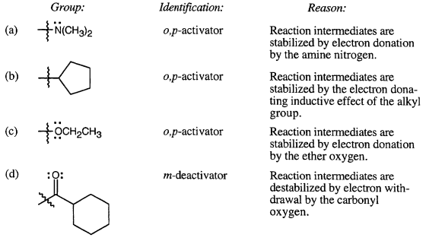

1. How might you synthesize the following compounds from benzene? (16%)

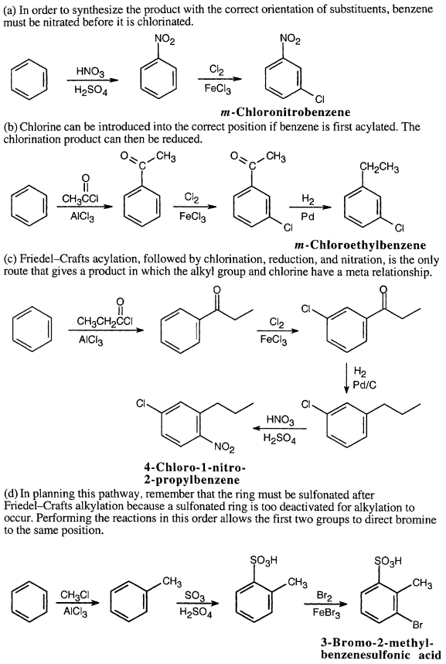

1. Predict the products of the following reaction. (20%)



1. Propose the mechanism of the following reaction. (12%)

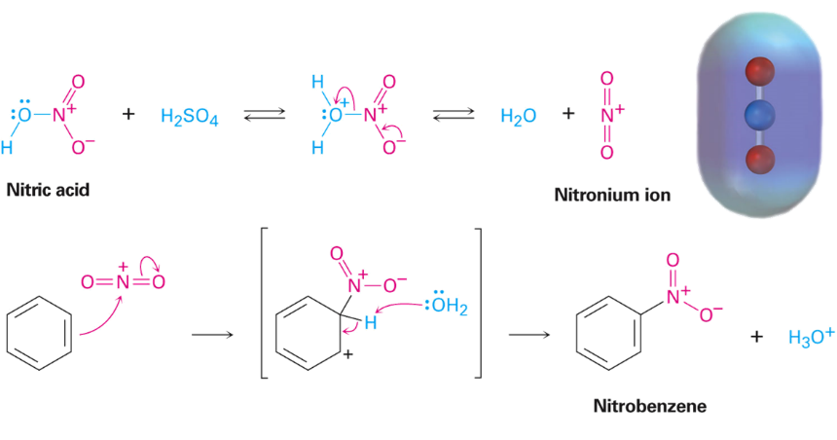

(b)

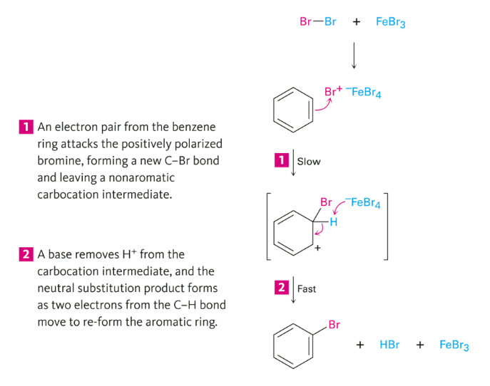

(c)

